Assignment - Using the Scientific Method in Your Life

Shaun Pritchard

Rasmussen College

PHY4060

Arunava Roy

November 19, 2020

**Assignment - Using the Scientific Method in Your Life**

For my experiment I will be using the observation of boiling water at 212° Fahrenheit . Question I want to ask is if water will boil faster at the same temperatures if salt(Sodium chloride) is added to it.

H0:  **Null Hypothesis :** The null hypothesis is that there will be no difference in how long it takes the water to boil, whether or not it has salt was added to it. The alternative hypothesis is that there will be a statistically significant difference in boiling times between the two scenarios.

Ha: **Test Hypothesis and Collect Data:** Fill two identical containers (stove-pots) with the same amount of room temperature water. Add a measured amount of 1table-spoon of salt to one of the containers. Place the two containers on the stove at the same temperatures. At regular intervals of 30 seconds, test the results and temperatures of the water and observe the status of the water in each pot. I will then continue until both have completely come to a boil.

H0:  Water with slat added will boil at the same rate and time as water without salt

Ha: Water with slat will boil faster.

**Experiment:**

I will do using three containers. I will take 1 cup of tap-water at room temperature and add 1 cup per container. The control pot container 1 will have no salt added. While container 2 and 3 will have even distributions of table salt added per container by adding 1 tbsp to container #2 and 2 tbsp of slat in container #3.

**Time it took for each container of water to reach a fully boiling level.**

|  |  |  |
| --- | --- | --- |
| **No Salt** | **Salt added(1tbsp)** | **Salt added (2tbsp)** |
| 2.46 *minutes/seconds* | 2.16 *minutes/seconds* | 2.06 *minutes/seconds* |

**Temperatures of water at 30 second time intervals***(All measurements where taken at 30 second intervals).*

|  |  |  |  |
| --- | --- | --- | --- |
| **Time/sec** | **No Salt** | **Salt added(1tbsp)** | **Salt added (2tbsp)** |
| *30 sec* | *78°* | *78°* | *78°* |
| *60 sec* | *105°* | *110°* | *111°* |
| *90 sec* | *189°* | *193°* | *193°* |
| *120 sec* | *196°* | *207°* | *210°* |
| *150 sec* | *214°* | *281°* | *282°* |

**Analyze Data:** when I observed the time, it took for each container of water to boil. I realized miniscule differences but the water with salt added started to boil before the water without salt added. It appears my Null hypothesis was correct for this 1-time experiment. Water boils at 212°F. my samples

**Conclusion:**

Based on the results of my experiment, I can conclude as to whether water with salt(Sodium chloride) boils faster than water without salt added to it. here are my findings and steps explained in my experiment.

**Report:**

Here is the process and documentation of the experiments I conducted.

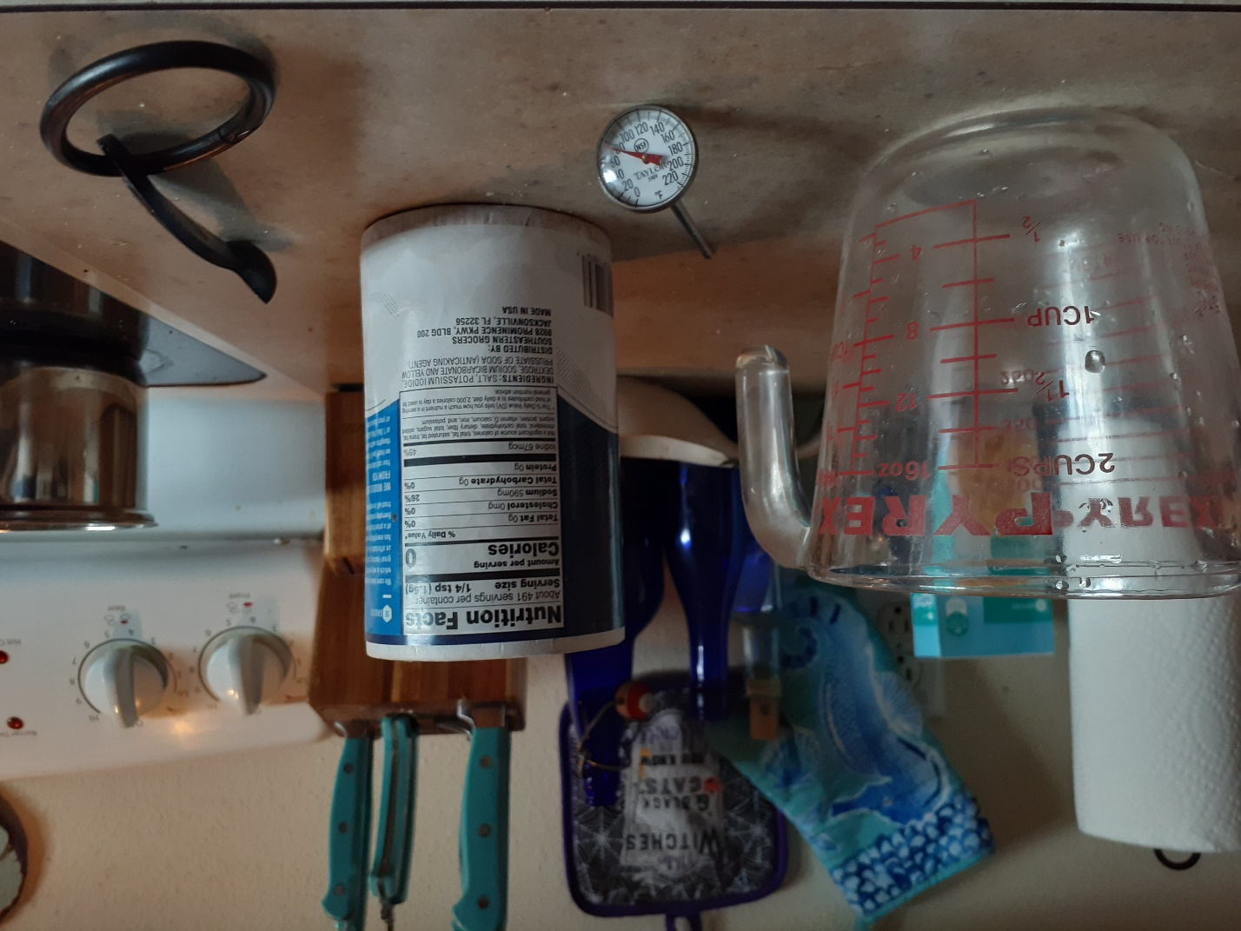

**Gathered all tools and equipment:**

* Measuring cup
* 1 tablespoon
* Thermometer
* Salt
* 3 containers(pots) on a stove

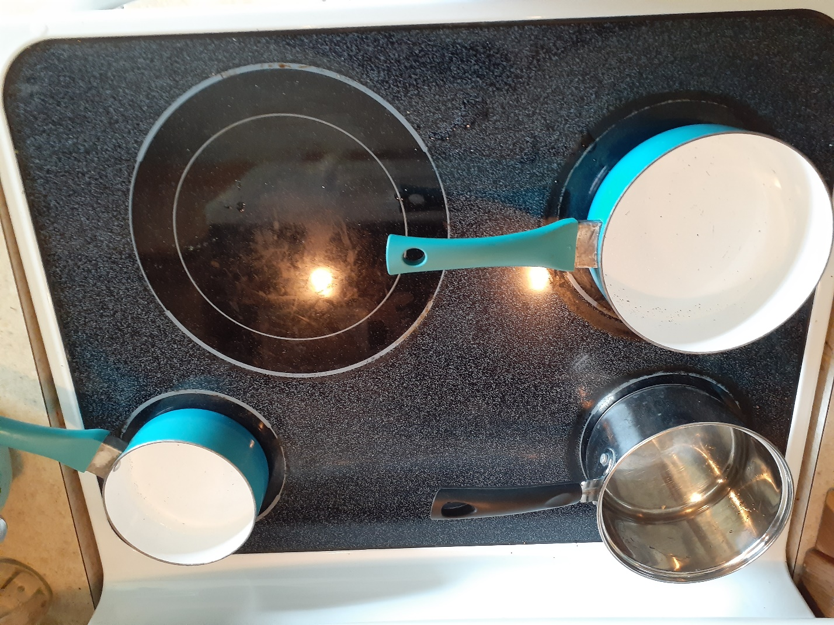

I emptied 1 cup of water in each container while the stove was off. The water measured a room temperature of 78° Fahrenheit. I then added **1 tbsp** of slat to bottom left container and **2 tbsp** of salt to the upper left container. The container on the right was the control pot which had no slat added to it.

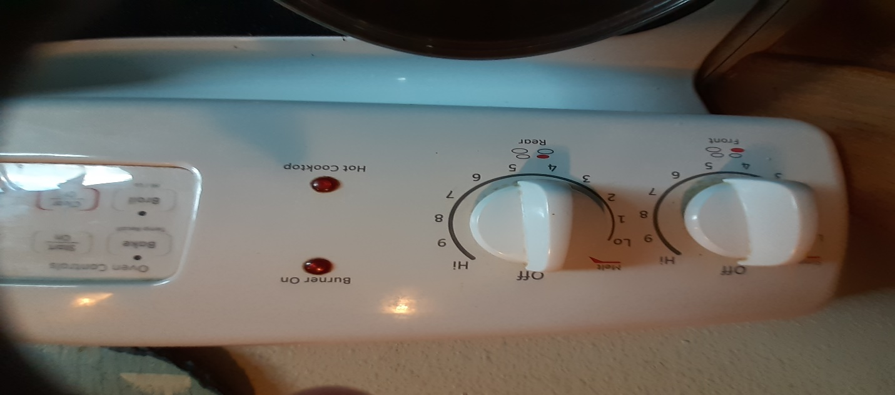

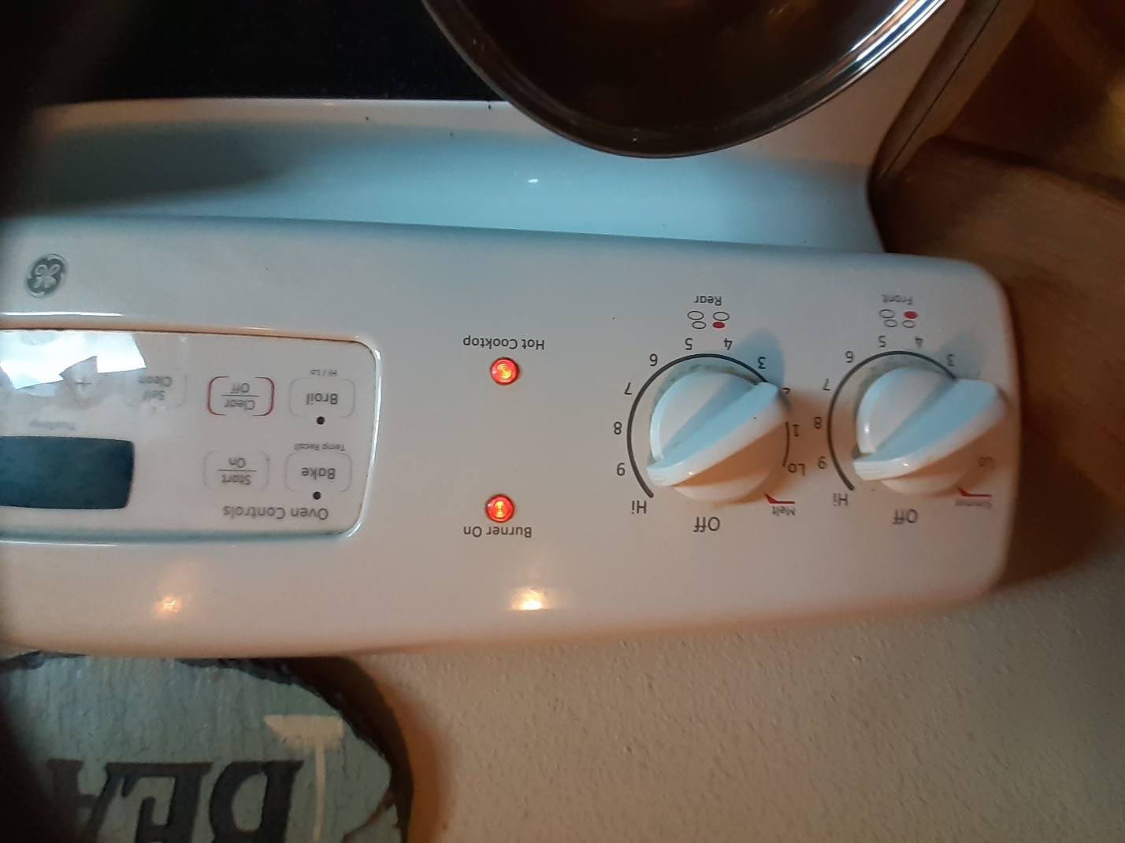

I then turned the over on high temperature after measuring the water temperature of each container of water. I also started my count down with a timer in intervals of 30 seconds.

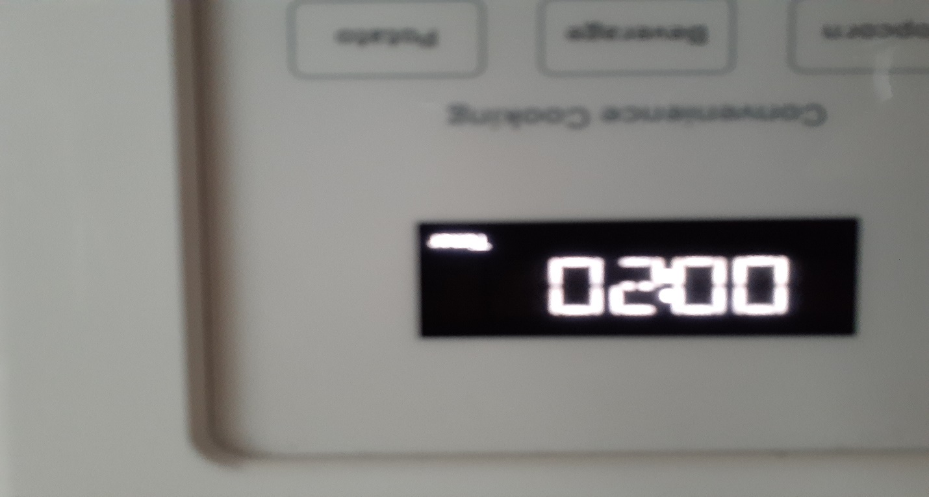

Every 30 seconds I measured the water temperature in each container while marking the results of the temperature down.

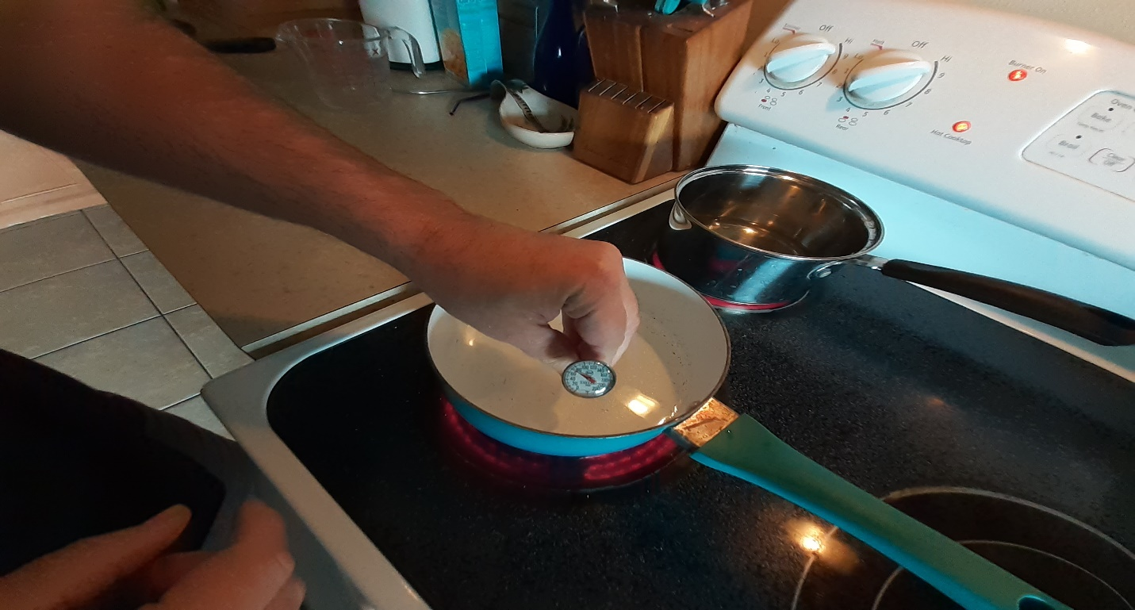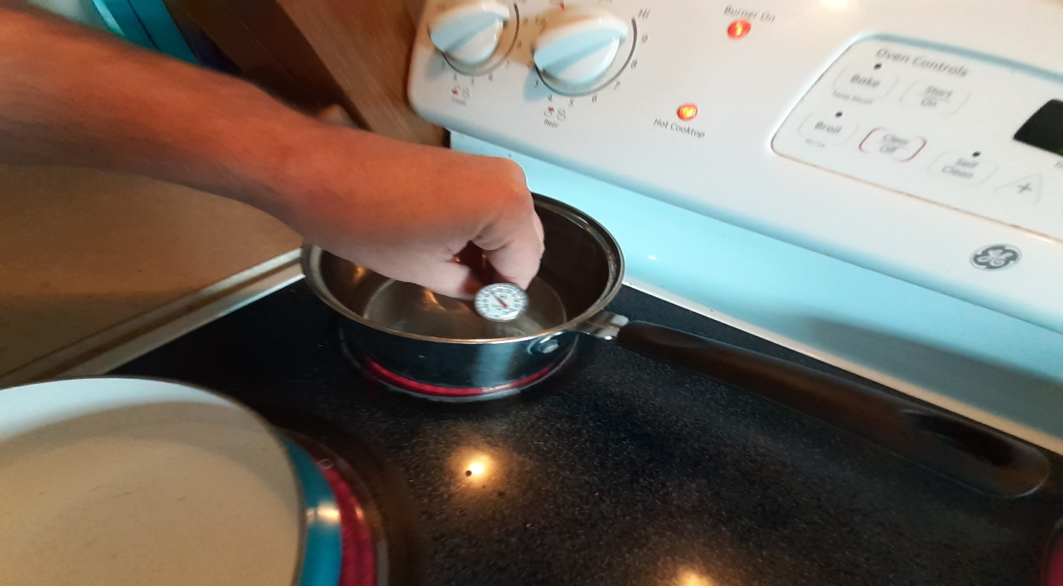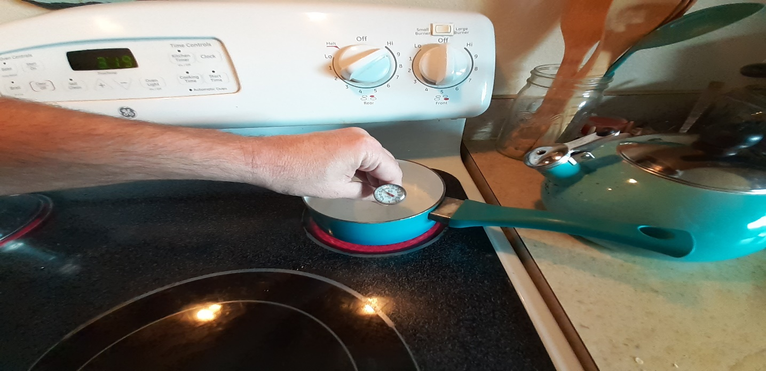

Once the last interval of 30 seconds was over at 150 seconds all containers had reached boiling points. I then recorded the final temperatures and ended the experiment and started reporting and calculating the data I received from it.

